The First National Conference on Mathematics and Artificial Intelligence (NCMAI’26) • Ouargla | Algeria • April 15 –16, 2026

Your Paper Title Here

A. Abcde^{1,∗}, C. Fghij², K. Mnopqr³

¹Dept. of Xxxxxxx, University of Tabcd, Country ²Dept. of Yyyyyyy, University of Wabcd, Country ³Dept. of Zzzzzzz, University of Yabcd, Country
*Corresponding author: email@address.xyz

ABSTRACT
The abstract (300–400 words) must be written in English and summarize the objectives, methods, and main results of the contribution.

Keywords: Keyword 1, Keyword 2, Keyword 3, Keyword 4.

Introduction

This template is provided to assist authors in preparing the extended abstract for the First National Conference on Mathematics and Artificial Intelligence (NCMAI’26). Authors are kindly requested to carefully follow the instructions below in order to ensure clarity, consistency, and a uniform appearance of all submitted manuscripts.

  - Authors must strictly use the official template and should not create their own document format or modify the layout.
  - The manuscripts should be written in clear, concise language. Authors are strongly encouraged to thoroughly review and proofread their work prior to submission.
  - Use the parenthetical format for citations within parentheses (e.g. Olver et al., 2019), and the narrative format for incorporating author names directly into the text (e.g. Lang (2012) demonstrated that...).
  - Every citation should correspond to a complete bibliography entry that includes all the necessary information, such as author names, publication year, title, source/journal name, page numbers and either the publisher or DOI. When organizing references, it may be helpful to add notes identifying the type of source (e.g. 'Book' or 'Journal Article') for easier categorization.

For further assistance, please refer to the NCMAI’26 website (https://ncmai.ens-ouargla.dz), or contact our staff at ncmai@ens-ouargla.dz.

Mathematical Expressions

Mathematical expressions should be formatted using appropriate equation tools. Simple equations can be included within a line of text, while more complex equations should be displayed on separate lines. Numbering should only be applied to equations that are referenced elsewhere in the document.
The following is an illustrative example of a mathematical expression:
$$u\left(t\right)=f\left(t\right)+\frac{1}{Γ\left(α\right)}\int_{0}^{t}{{\left(t-s\right)}^{α-1}K\left(t,s\right)u\left(s\right)ds} (1)$$

Figures and Tables

Figures and tables must be clear, readable, and referenced in the text. Include captions, axis labels, units, and legends if needed.
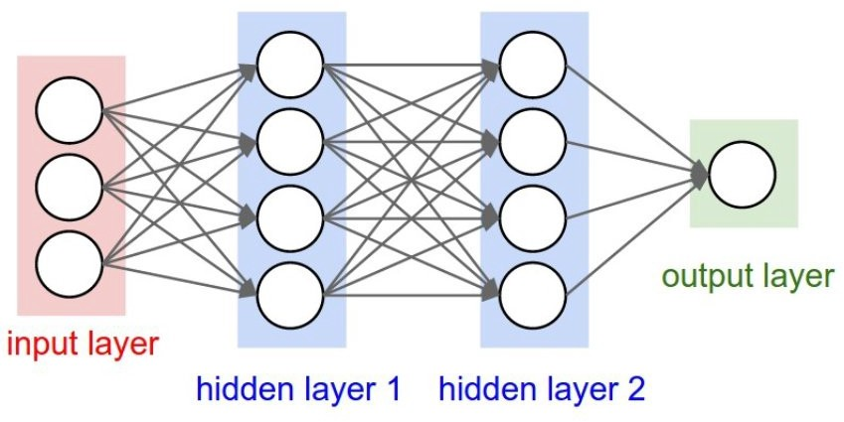

Figure 1. Example of a figure.

Table 1. Example of a table.

 | Column 1 | Column 2 | Column 3 | Column 4
Row 1 | 45 | 30 | -12.67 | 1.4
Row 2 | 225 | 55.5 | 75 | 23.36
Row 3 | -65.58 | 0.146 | 64 | 11

Acknowledgements

The authors would like to acknowledge...

References

Olver, P. J., Shakiban, C., & Townsend, A. (2019). Numerical solution of differential equations. Cam- bridge, UK: Cambridge University Press.
Boyd, S., & Vandenberghe, L. (2004). Convex Optimization. Cambridge, UK: Cambridge University Press.
Lang, S. (2012). Algebra. New York, USA: Springer.
LeCun, Y., Bengio, Y., & Hinton, G. (2015). Deep learning. Nature, 521(7553), 436–444. https://doi.org/10.1038/nature14539
Rasmussen, C. E., & Williams, C. K. I. (2006). Gaussian Processes for Machine Learning. MIT Press.
Armstrong, R., & Hopkinson, R. (1988). Laser diagnostics for sprays and atomization. In J. V. Beck (Ed.), Laser Applications in Fluid Mechanics (pp. 45–78). Berlin, Germany: Springer.
Goodfellow, I., Bengio, Y., & Courville, A. (2016). Deep learning for computer vision. In Proceedings of the 33rd International Conference on Machine Learning (ICML) (pp. 1–10). New York, USA.

